**GIT AND GITHUB**

**Assignment#2**

**COURSE- JAVA WITH DSA SYSTEM DESIGN**

**SUBMITTED BY:**

**SAMIM MONDAL**

**SUBMITTED TO:**

**HYDER ABBAS**

**1.What is Git?**

* Git is a DevOps tool used for source code management. It is a free and open-source version control system used to handle small to very large projects efficiently. Git is used to tracking changes in the source code, enabling multiple developers to work together on non-linear development.
* Git was created by Linus Torvalds in 2005 to develop Linux Kernel. It is also used as an important distributed version-control tool for the DevOps.

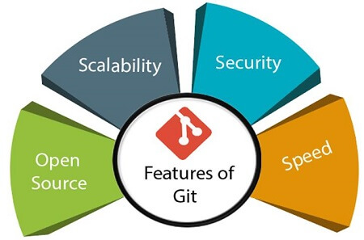

**2. What do you understand by the term ‘Version Control System’?**

* A version control system is a software that tracks changes to a file or set of files over time so that you can recall specific versions later. It also allows you to work together with other programmers.
* The version control system is a collection of software tools that help a team to manage changes in a source code. It uses a special kind of database to keep track of every modification to the code.
* Developers can compare earlier versions of the code with an older version to fix the mistakes.
* Some key benefits of having a version control system are as follows.
* Complete change history of the file
* Simultaneously working
* Branching and merging
* Traceability

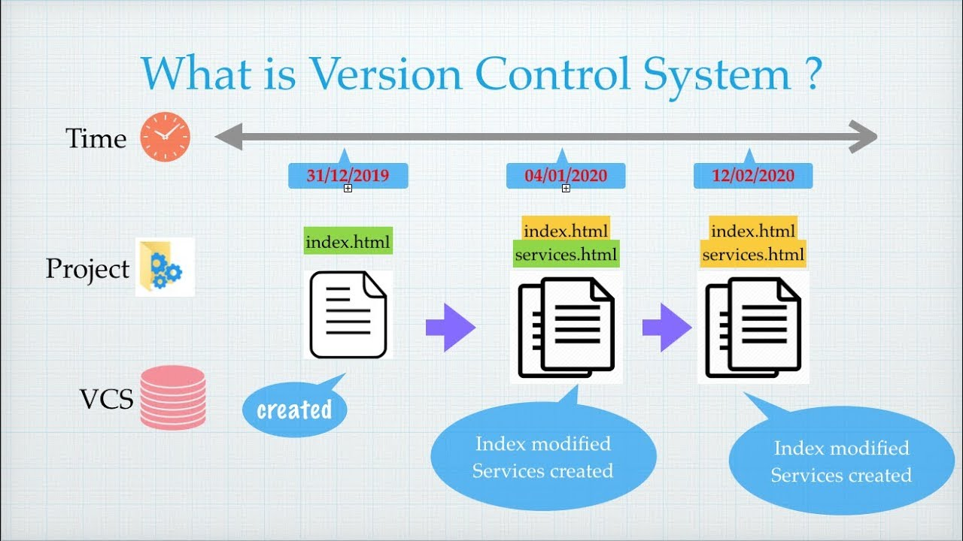

# **4.What is GitHub?**

* GitHub is a Git repository hosting service. GitHub also facilitates with many of its features, such as access control and collaboration. It provides a Web-based graphical interface.

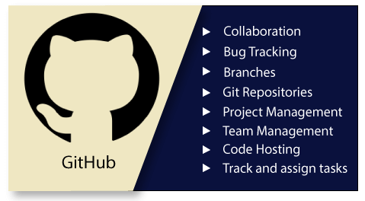

**5.Mentions some popular Git hosting services?**

* Bitbucket.
* GitLab.
* Perforce.
* Beanstalk.
* Amazon AWS Code Commit.
* Codebase.
* Microsoft Azure DevOps.
* Source Forge.

**6.Different types of version control system?**

* Localized version Control System
* Centralized version control systems
* Distributed version control systems

## Localized Version Control Systems

* The localized version control method is a common approach because of its simplicity. But this approach leads to a higher chance of error.
* The major drawback of Local VCS is that it has a single point of failure.

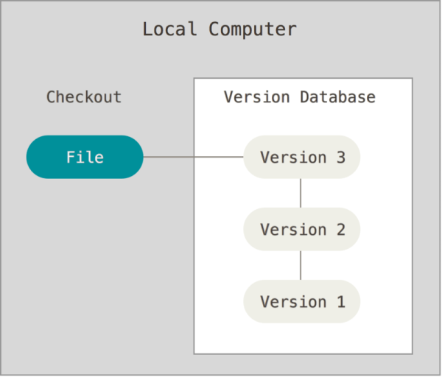

## Centralized Version Control System

* The developers needed to collaborate with other developers on other systems. The localized version control system failed in this case. To deal with this problem, Centralized Version Control Systems were developed.

# Centralized version control systems have many benefits, especially over local VCSs.

* Everyone on the system has information about the work what others are doing on the project.
* Administrators have control over other developers.
* It is easier to deal with a centralized version control system than a localized version control system.
* A local version control system facilitates with a server software component which stores and manages the different versions of the files.

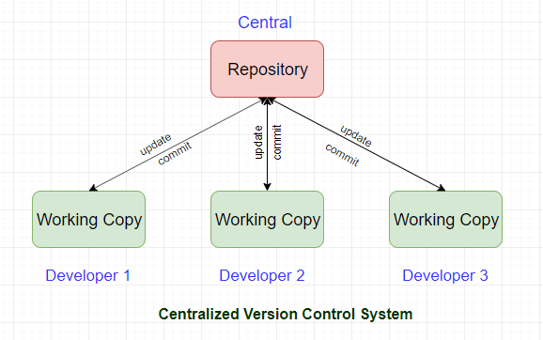

## Distributed Version Control System

* In a Distributed Version Control System (such as Git, Mercurial, Bazaar or Darcs), the user has a local copy of a repository. So, the clients don't just check out the latest snapshot of the files even they can fully mirror the repository. The local repository contains all the files and metadata present in the main repository.

**6.What benefits come with using Git?**

* Version control helps teams solve these kinds of problems, tracking every individual change by each contributor and helping prevent concurrent work from conflicting. Changes made in one part of the software can be incompatible with those made by another developer working at the same time.

**7.What is a Git repository?**

* In Git, the repository is like a data structure used by VCS to store metadata for a set of files and directories. It contains the collection of the files as well as the history of changes made to those files. Repository in Git is considered as your project folder. A repository has all the project-related data. Distinct projects have distinct repositories.

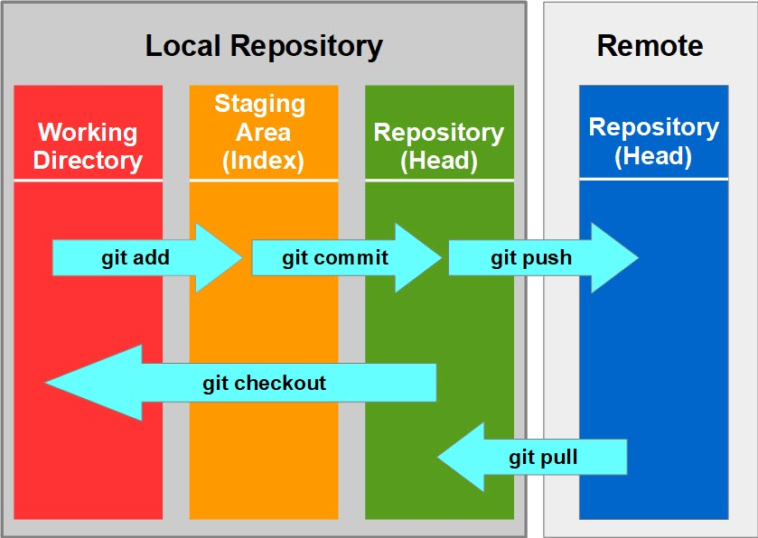

**8.How can you initialize a repository in Git?**

* The git init command creates a new Git repository. It can be used to convert an existing , unversioned project to a Git repository or initialize a new, empty repository.

# THANK YOU!